System Requirement Specification

[**www.mercurytours.com**](http://www.mercurytours.com) is the most preferred website for the tours and travels.

This website offers user to book the entire the Tour from flight ticket booking to complete accommodation. User can also include the cruise as part of the Adventure.

Also **‘Car Rentals’** is the part of this website. For all this User must register to our website to experience the features.

**HOME PAGE:**

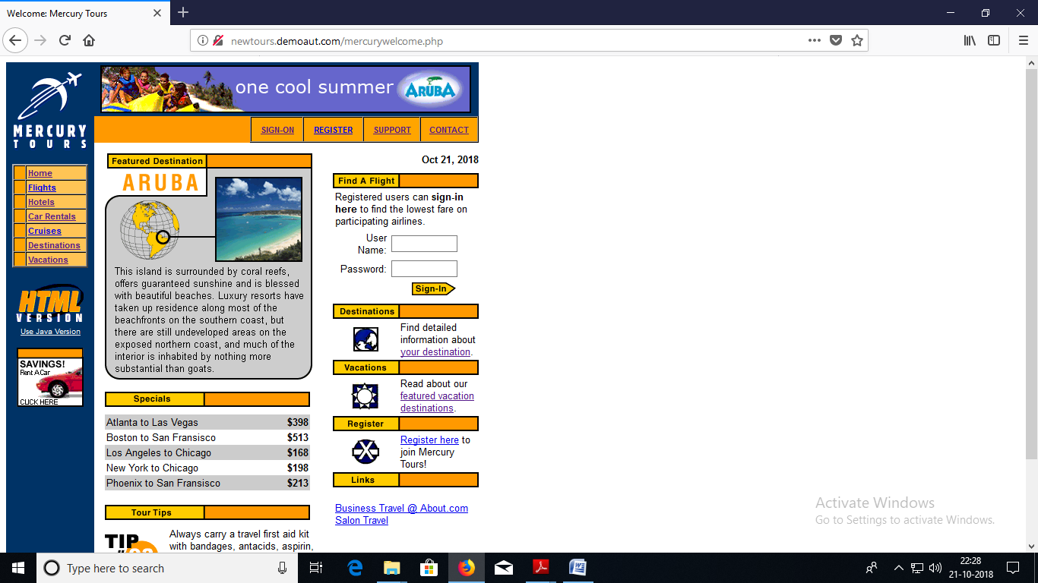

**Steps for the USER registration and Flight booking:-**

1. The user must visit the [**www.mercurytours.com**](http://www.mercurytours.com)**.** To **Register**, click the ‘Register’ button or on the navigation menu or Click on the ‘Register_now’ link present at the Bottom of the page in the Link section.
2. The form is divided into three parts firstly ‘Contact Information’ secondly ‘Mailing Information’ and last part ‘User Information’.
3. User must enter all the details as all fields are mandatory.
4. In the last part the user must choose a Username and password with the combination of alphabet and numbers.
5. The phone number should be of 10- Digits and email should accept the alpha-numeric characters.
6. After the Details are filled user must click on the ‘**SUBMIT**’ button to register.
7. Then the user must be directed to next page where the USERNAME will be displayed along with the registration confirmation message.
8. After the USER registration user must go to the ‘**SIGN_ON**’ option present in the navigation menu.
9. USER must enter the **USERNAME** and a **PASSWORD** associated with it.
10. On the left hand side there will be options available to the user such as

|  |  |
| --- | --- |
|  | [Home](http://newtours.demoaut.com/mercurywelcome.php) |
|  | [Flights](http://newtours.demoaut.com/mercuryreservation.php) |
|  | [Hotels](http://newtours.demoaut.com/mercuryunderconst.php) |
|  | [Car Rentals](http://newtours.demoaut.com/mercuryunderconst.php) |
|  | [Cruises](http://newtours.demoaut.com/mercurycruise.php) |
|  | [Destinations](http://newtours.demoaut.com/mercuryunderconst.php) |
|  | [Vacations](http://newtours.demoaut.com/mercuryunderconst.php) |

1. Select the ‘**Flights**’ from the menu. USER must select the type of trip ‘**ROUND**’ or ‘**SINGLE’**.
2. There will be two parts need to be filled

* Flight details.
* Preferences.

1. In the first part if USER selects **ROUND** trip then USER need to select the number of passenger’s from the drop down list. Select the airport from where the USER need to departure with the date and also the round trip destination will be same as it is the round trip with proper return date. IF USER selects **SINGLE** trip then USER need to select the number of passenger’s from the drop down list. Select the airport from where the USER need to departure along with the proper date and the destination airport.
2. In the second part USER need to select the preferences such as Service Class

* Economy Class.
* Business Class.
* First Class.

1. Lastly the USER should to select the ‘**Airline’** from the Drop down menu or else NO- Preference. If USER selects NO-Preference then after the click of CONTINUE button the **USER** will get the option to select the airlines. After all these details are filled by the user need to click on the ‘**CONTINUE**’ Button.
2. The User will be directed on the next page where his **Airlines** details will be shown. If user had selected airline preference details will be shown of that airlines if available or else other options will be listed from which user need to select the one option in **DEPATURE** as well as in **RETURN** and then click on **CONTINUE**’ button.
3. The User will be directed to the next page where he need to enter the details of the passengers, Payment details of the Credit Card, Billing address and Delivery address then click on the ‘**SECURE PURCHASE**’ button to

**Refer to the Images for the steps:-**

* GOTO the website [www.mercurytours.com](http://www.mercurytours.com) and click on the Register button

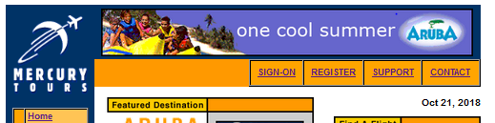

* User must fill the details.

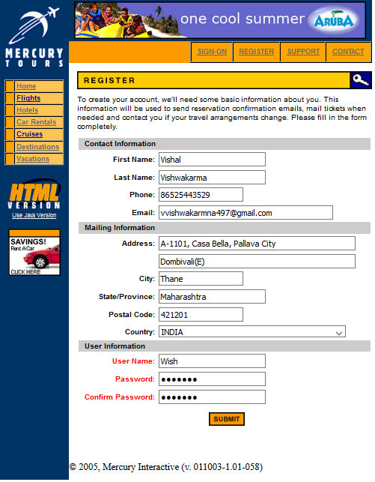

* User is directed to next page with registration confirmation along with the **USERNAME.**

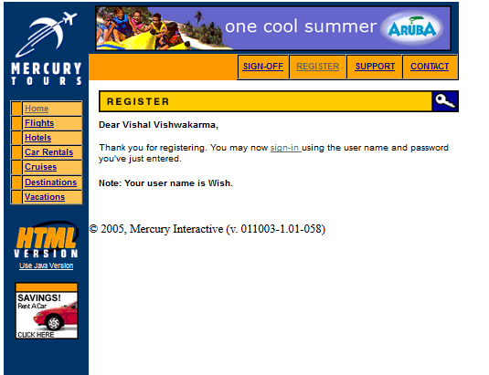

* Click on the Flight from the left navigation menu and fill the details and click on CONTINUE button.

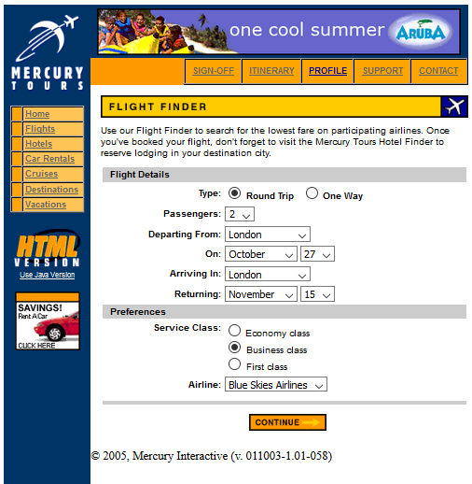

* The User will be directed to next page where the airline details will be mentioned as shown below and then click on the CONTINUE button to proceed.

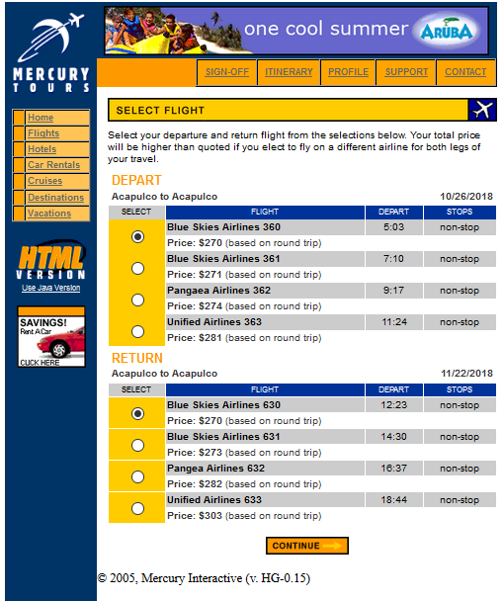

* ON click of the **CONTINUE** button the user will be directed on the next page where he need to enter the details of the passenger’s, Payment details, billing and Delivery address then click on the **SECURE PURCHASE** button.

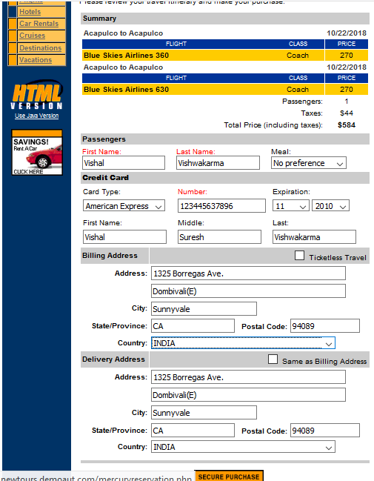

* The user will be directed on the acknowledgement page where the **BOOKING** details will be shown, also **USER** can take the Print out of the **BOOKING** by clicking on the **PRINT** icon on the top right corner.

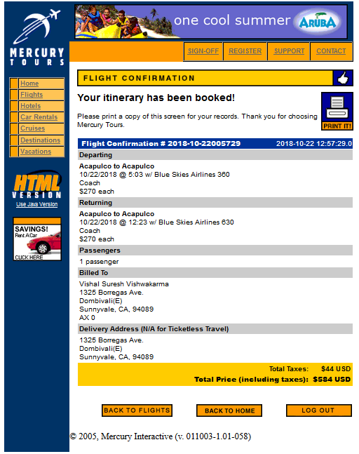

**Rules:-**

**FOR THE REGISTRATION PAGE**

1. Every Phone **NUMBER** field should accept 10 – Digits only.
2. Every **Name** field should accept **Alphabets** only with max length of 20 characters.
3. Email field should accept the alpha-numeric character’s with appropriate pattern.
4. Postal code should be of 6-Digits only.
5. USERNAME should accept alphabets and PASSWORD should accept alpha-numeric character with maximum of 8 characters. If the password and confirm password doesn’t matches it should throw error.

**FOR SIGN-UP PAGE**

1. The Username field should accept alphabets.
2. Password field should accept’s alpha-numeric character’s.

**FOR THE FLIGHT BOOKING PROCESS**

* USER must select options on the page.
* Date of departure must be less than date of return.

|  |  |
| --- | --- |
| **Departure** | Acapulco, Frankfurt, London, New York, Paris |
| Portland, San Francisco, Seattle, Sydney , Zurich |
| **Arrival** | Acapulco, Frankfurt, London, New York, Paris |
| Portland, San Francisco, Seattle, Sydney , Zurich |
| **Airlines** | No-preference. |
| Blue Skies Airlines. |
| Unified Airlines. |
| Pangea Airlines. |

* One option should be selected or-else it should throw error.
* In the passengers details the name field should accept alphabets only.

**For meal the user need to select the options available.**

|  |  |
| --- | --- |
| **Meal** | No preference |
| Bland |
| Diabetic |
| Hindu |
| Kosher |
| Low Calorie |
| Low Cholesterol |
| Low Sodium |
| Muslim |
| Vegetarian. |
| **Credit Card** | American Express |
| Master Card |
| Visa |
| Discover |
| Diner’s Club |
| Carte Blanche |